
Web Development
TASK NO 2

July 15, 2026

<!DOCTYPE html>
Question no 1 – Code
<html lang="en">
<head>
<meta charset="UTF-8">
<meta name="viewport" content="width=device-width, initial-scale=1.0">
<title>Mera Pehla Webpage</title>
</head>
<body>

<h1>Main Title</h1>
<p>This is the Main Title of our page.</p>

<h2>Sub-heading</h2>
<p>These are the Major Sections of our page</p>

<h3>Sub-sections</h3>
<p>These are Sub-sections that sit inside your <h2> topics.</p>

<h4>Sub-Sub-Sections</h4>
<p>We will use <h4> when we are writing detailed guides.</p>

<h5>Deep Sub-Sections</h5>
<p>It is mostly used in highly technical websites.Like, online documentation</p>

<h6>The Lowest Level Heading</h6>
<p>These are the smallest heading of HTML.</p>
</body>
</html>

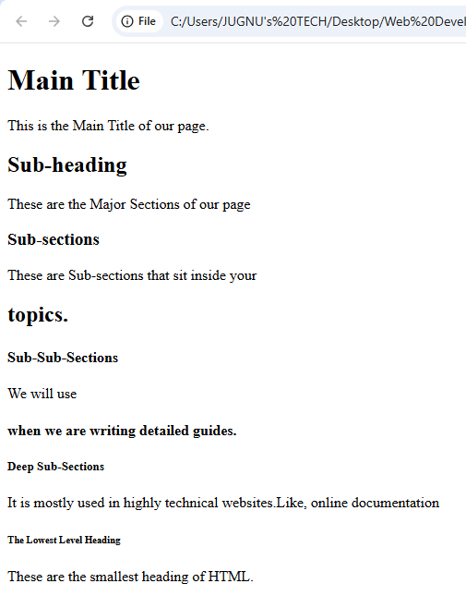
Question no 1 - Output
<!DOCTYPE html>
Question no 2 - Code
<html lang="en">
<head>
<meta charset="UTF-8">
<meta name="Digital Marketing." content="width=device-width, initial-scale=1.0">
<title>Display Image</title>
</head>
<body>

<img src="file:///C:/Users/JUGNU's%20TECH/Desktop/Web%20Development/Back-end.jpg.jpg"
alt="A great image everything is clear in this image."
width="600" height="400">

</body>
</html>
Question no 2 - Output

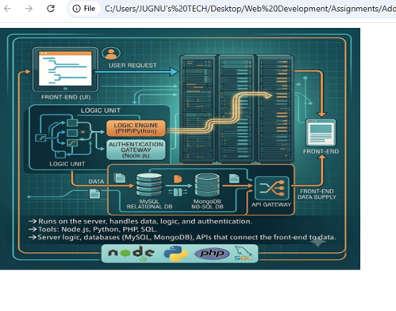
Question no 3 - Code

<!DOCTYPE html>
<html lang="en">
<head>
<meta charset="UTF-8">
<meta name="viewport" content="width=device-width, initial-scale=1.0">
<title>Ordered and Unordered Lists</title>
</head>
<body>

<h2>My Favorite Fruits (Unordered List)</h2>
<ul>
<li>Mango</li>
<li>Apple</li>
<li>Banana</li>
</ul>

<hr> <h2>Steps to Make Tea (Ordered List)</h2>
<ol>
<li>Boil water in a pot.</li>
<li>Add tea leaves or a teabag.</li>
<li>Add milk and sugar to taste.</li>
<li>Pour into a cup and serve.</li>
</</ol>

</body>
</html>

Question no 3 - Output

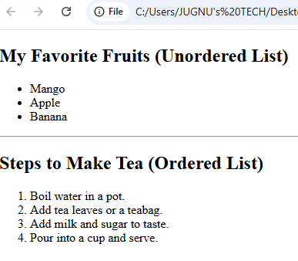
Question no 4 - Code

<!DOCTYPE html>
<html lang="en">
<head>
<meta charset="UTF-8">
<meta name="viewport" content="width=device-width, initial-scale=1.0">
<title>Internal and External Links</title>
</head>
<body>

<h1>Working with Links in HTML</h1>

<h2>External Link Example</h2>
<p>Click the link below to visit Google. It will open in a new tab:</p>
<a href="https://www.google.com" target="_blank">Go to Google</a>

<hr>

<h2>Internal Link Example</h2>
<p>Click below to go to another page of your own website (e.g., about.html):</p>
<a href="about.html">Go to About Page</a>

</body>
</html>
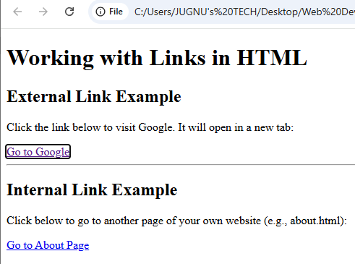
Question no 5 - Code
Question no 4 - Output
<!DOCTYPE html>
<html lang="en">
<head>
<meta charset="UTF-8">
<meta name="viewport" content="width=device-width, initial-scale=1.0">
<title>Weekly Timetable</title>
<style>
table {
width: 100%;
border-collapse: collapse;
font-family: Arial, sans-serif;
margin-top: 20px;
}
th, td {
border: 1px solid #dddddd;
text-align: center;
padding: 12px;
}
th {
background-color: #f2f2f2;
font-weight: bold;
}
tr:nth-child(even) {
background-color: #fafafa;
}
</style>
</head>
<body>
<h1>Weekly Class Timetable</h1>
<table>
<thead>
<tr>
<th>Day / Time</th>
<th>09:00 AM - 10:30 AM</th>
<th>10:30 AM - 12:00 PM</th>
<th>12:00 PM - 01:30 PM</th>
</tr>
</thead>
<tbody>
<tr>
<td><strong>Monday</strong></td>
<td>HTML Basics</td>
<td>CSS Styling</td>
<td>Lab Practice</td>
</tr>
<tr>
<td><strong>Tuesday</strong></td>
<td>Database Systems</td>
<td>Digital Logic</td>
<td>Web Development Lab</td>
</tr>
<tr>
<td><strong>Wednesday</strong></td>
<td>Mathematics</td>
<td>English Composition</td>
<td>Self Study</td>
</tr>
<tr>
<td><strong>Thursday</strong></td>
<td>HTML Basics</td>
<td>CSS Styling</td>
<td>Project Work</td>
</tr>
<tr>
<td><strong>Friday</strong></td>
<td>Database Systems</td>
<td>Digital Logic</td>
<td>Weekly Quiz</td>
</tr>
</tbody>
</table>

</body>
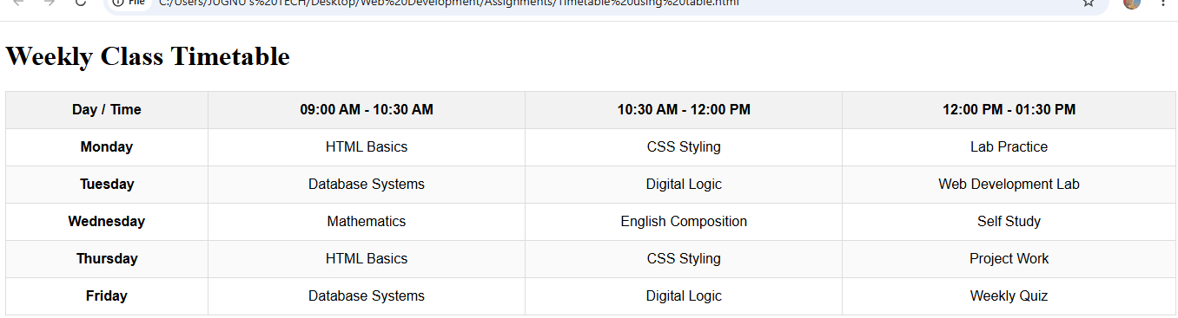
</html>
Question no 5 - Output
Question no 6 - Code
<!DOCTYPE html>
<html lang="en">
<head>
<meta charset="UTF-8">
<meta name="viewport" content="width=device-width, initial-scale=1.0">
<title>Registration Form</title>
<style>
/* Choti si simple styling taake form clean dikhe */
body { font-family: Arial, sans-serif; margin: 50px; }
form { max-width: 300px; }
input, select, button { margin-bottom: 15px; }
</style>
</head>
<body>

<h2>Registration Form</h2>

<form action="/register" method="post">
<label for="name">Full Name</label><br>
<input type="text" id="name" name="name" placeholder="Jamil Raza" required><br>

<label for="email">Email</label><br>
<input type="email" id="email" name="email" required><br>

<label for="pw">Password</label><br>
<input type="password" id="pw" name="password" required><br>

<label>Gender:</label><br>
<input type="radio" id="male" name="gender" value="male">
<label for="male">Male</label>
<input type="radio" id="female" name="gender" value="female">
<label for="female">Female</label><br><br>

<input type="checkbox" id="terms" name="terms" required>
<label for="terms">Accept Terms</label><br><br>

<button type="submit">Register</button>
</form>

</body>
</html>
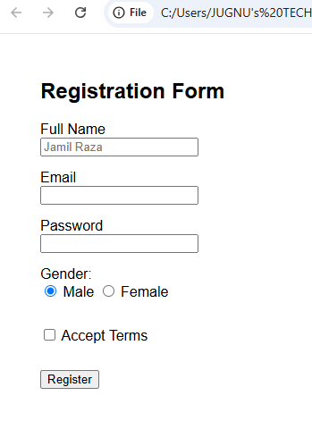
Question no 6 - Output
Question no 7 - Code
<!DOCTYPE html>
<html lang="en">
<head>
<meta charset="UTF-8">
<meta name="viewport" content="width=device-width, initial-scale=1.0">
<title>Embed YouTube Video</title>
<style>
body {
font-family: Arial, sans-serif;
text-align: center;
margin-top: 50px;
}
iframe {
border: 2px solid #ccc;
border-radius: 8px;
}
</style>
</head>
<body>

<h2>My Favorite YouTube Video</h2>

<iframe
width="560"
height="315"
src="https://www.youtube.com/embed/dQw4w9WgXcQ"
title="YouTube video player"
frameborder="0"
allow="accelerometer; autoplay; clipboard-write; encrypted-media; gyroscope; picture-in-picture; web-share"
allowfullscreen>
</iframe>

</body>
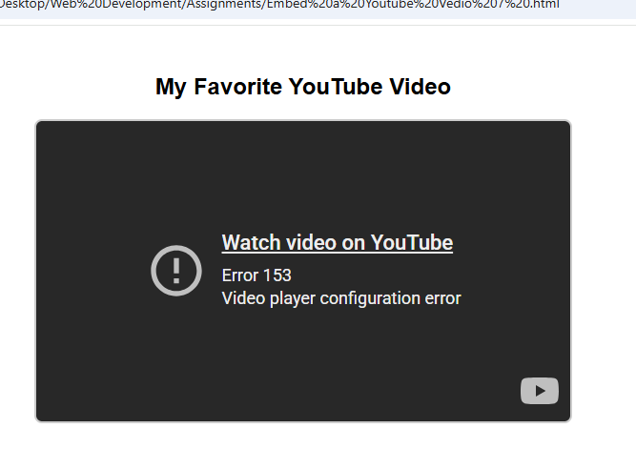
</html>
Question no 7 - Output

Question no 8 - Code
<!DOCTYPE html>
<html lang="en">
<head>
<meta charset="UTF-8">
<title>Navigation Menu</title>
<style>
/* Chota aur simple style horizontal menu ke liye */
nav { background: #333; padding: 10px; }
nav a { color: white; text-decoration: none; margin-right: 15px; font-family: sans-serif; }
nav a:hover { color: lightgray; }
</style>
</head>
<body>

<nav>
<a href="#home">Home</a>
<a href="#about">About</a>
<a href="#services">Services</a>
<a href="#contact">Contact</a>
</nav>
<h1>This is Navigation Menu</h1>
</body>
</html>
Question no 8 - Output

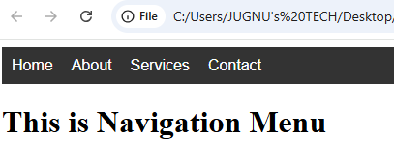

Question no 9 - Code

<!DOCTYPE html>
<html lang="en">
<head>
<meta charset="UTF-8">
<title>About Me</title>
<style>
/* Choti aur clean design */
.about-section {
max-width: 500px;
margin: 50px auto;
font-family: sans-serif;
text-align: center;
padding: 20px;
border: 1px solid #ddd;
border-radius: 8px;
}
.about-section img {
width: 100px;
height: 100px;
border-radius: 50%;
object-fit: cover;
}
</style>
</head>
<body>

<section class="about-section">
<img src="https://via.placeholder.com/100" alt="Profile Picture">
<h2>About Me</h2>
<p>Hi, I am a web developer passionate about coding and building clean, responsive user interfaces.</p>
</section>
</body>
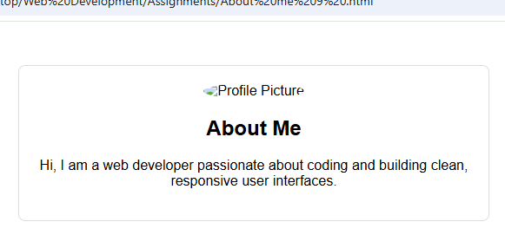
</html>
Question no 9 - Output
Question no 10 - Code

<!DOCTYPE html>
<html lang="en">
<head>
<meta charset="UTF-8">
<title>Resume</title>
<style>
body { font-family: sans-serif; max-width: 500px; margin: 30px auto; padding: 10px; }
h2 { border-bottom: 1px solid #999; margin-top: 15px; }
</style>
</head>
<body>

<h1>Jamil Raza</h1>
<p>Email: jamil@email.com | Phone: +12345678</p>

<h2>Education</h2>
<p><strong>BS Computer Science</strong> - XYZ University (2022 - 2026)</p>

<h2>Experience</h2>
<p><strong>Web Developer Intern</strong> - Tech Corp (2025 - Present)</p>
<ul>
<li>Built responsive web pages using HTML and CSS.</li>
</ul>

<h2>Skills</h2>
<p>HTML, CSS, JavaScript, Git</p>

</body>
</html>
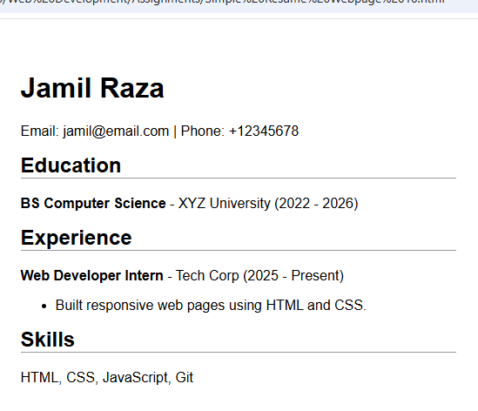
Question no 10 - Output

